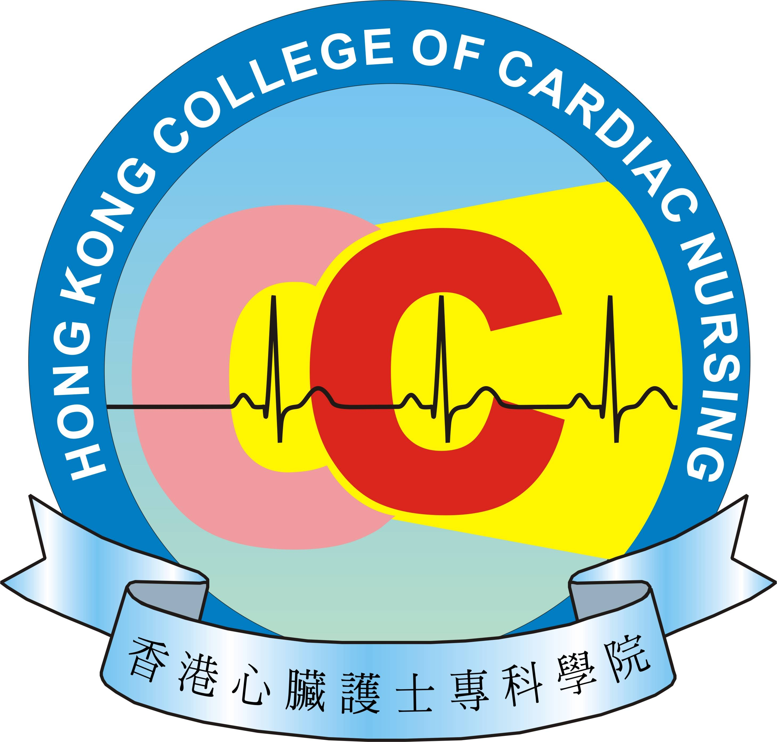
APPLICATION FOR
FELLOW MEMBER
(Under New Pathway)

- Personal Particulars

* Please type or complete the form in BLOCK LETTERS and circle as appropriate
Title:* Ms /Mr /Mrs /Dr/Prof | Surname: |  |  |  |  |  | Given Name:
Name in Chinese: |  |  |  |  |  |  | Sex * F / M
Job Title: | Current Working Place/Area:
HK ID No.: |  |  |  |  |  | First 4 digits of your HKID number
  ( )
Correspondence Address:
Contact: | Mobile Phone No.: |  |  |  |  |  |  | Office: Tel. No.:
 | Email Address:
Registration No. of Registered Nurse* / Midwives* Certificate Issued by Nursing / Midwives Council of Hong Kong : ( add two spaces for the number of the above two)
Expiry Date of Practising Certificate: |  |  |  |  |  |  |  |  | (DD/MM/YY)
HKAN Ordinary Membership No.:

- Academic and Professional Qualifications

(The following entries should be written in descending chronological order)
 | Course / Program Title | Training Institution / Country | Qualification Obtained /  Year
A. Nursing related Academic & Professional Qualifications | 1.
A. Nursing related Academic & Professional Qualifications | 2.
A. Nursing related Academic & Professional Qualifications | 3.
B. Related Specialty Training | 1.
B. Related Specialty Training | 2.
B. Related Specialty Training | 3.

- Post-registration Working Experience in Nursing Relevant to Application

(The following entries should be written in descending chronological order)
Position | Specialty / Department | Working Institution / Hospital | Month / Year
1.

2.

3.

4.

- Significant Contributions to Nursing Profession
(maximum 3 most significant ones in each item; at least one in any two items)
- In leadership position of specialty-related activities e.g. in-charge of service or project, or leaders of clinical teams
Position | Activity Title | Period / Year
1.

2.

3.

- Invited member in local, national and/or international initiatives e.g. Council Member; invited member of conference / seminar Organizing committee or invited panel member of professional bodies.
Position | Activity Title | Period / Year
1.
2.

3.

- Demonstrated contributions in nursing practice and service development e.g. being a specialty mentor, speaker, facilitator, moderator, coordinator or organizer in specialty related training and development programs; or paper submission on innovative nursing practice.
Position | Activity Title | Period / Year
1.

2.

3.

- Others Contributions :

SUPPORTIVE DOCUMENTS (Mandatory)
* Delete as appropriate
I enclose the following documents to support my application:
 (1) certified true copy of a valid RN* / RM* Registration certificate
 (2) certified true copy of a valid RN* / RM* practicing certificate
 (3) certified true copy of HKAN Certificate of Ordinary Membership
 (4) certified true copy of the certificate of the highest academic qualification
 (5) certified true copy of proof of passing the certificate examination (150MCQs)
 (6) certified true copy of specialty nursing related certificate(s)
 (7) copy of curriculum vitae
 (8) evidence of completed 250 hours more of clinical practice in the related specialty
 (9) evidence of achieved 60 CNE points within 3-year cycle which include 45 CNE points are ____________________________specialty related.
 (10) others

DECLARATION
* Delete as appropriate
- I hereby declare that I agree to provide the above information to the Hong Kong College of _____________________________ and the information provided in support of this application is accurate to this date.
- I understand that the information provided herewith will be forwarded to the Hong Kong Academy of Nursing for processing my membership certification examination application.

- I hereby declare that:
3.1 I *have / have never been convicted of a criminal offence punishable with imprisonment (irrespective of whether actually sentenced to imprisonment) in Hong Kong or elsewhere.
3.2 I *have / have never been found guilty of professional misconduct by any professional body in Hong Kong or elsewhere.
- I understand that it is my responsibility to inform the College for any change in the above information, such as place of work, correspondence address and additional related qualification(s), etc. The College will not have to be responsible for any issues arise as a result of my failure to inform.

Signature of Applicant Date

You have to apply for fellowship within 3 years upon become eligible, otherwise the eligibility would lapse. You also eligible to apply for the ‘Fellow Membership’ after passing the ‘Fellow Exit’ Assessment.

Referee (Recommended and supported by two active Fellow Members of The Hong Kong College of _________________________________)

Referee 1 (Professionally Affiliated)

Name: |  |  | Position:
Signature: |  |  | Hospital / Institution:
Contact phone no.: |  |  | Fellowship No:
Email Address:

Referee 2 (Professionally Affiliated)

Name: |  | Position:
Signature: |  | Hospital / Institution:
Contact phone no.: |  | Fellowship No:
Email Address:

I enclose herewith a crossed cheque for HK$2000 with cheque no. of _______________Bank to be payable to Hong Kong College of Cardiac Limited as the assessment fee. (assessment fee is non-refundable once you are accepted for the assessment)

Please mail this application form with a crossed cheque of HK$2000 and the supportive documents to The Hong Kong College of Cardiac Limited
Administrative Office, Hong Kong College of Cardiac Nursing,
Unit 4-5, 6th Floor, Nan Fung Commercial Centre,
19 Lam Lok Street, Kowloon Bay, Kowloon

Guideline for the Use of Personal Data

The Hong Kong College of Cardiac Nursing Limited undertakes to comply with the requirements of the Personal Data (Privacy) Ordinance to ensure that personal data are accurate and securely kept. To ensure you are well informed of the personal data as collected, please read through this guideline.

Purpose of collection and guideline for use of personal data
1. The Hong Kong College of Cardiac Nursing Limited will use personal data collected from a data subject for the purposes for which it is collected.
2. To provide personal data to the Hong Kong College of Cardiac Nursing Limited is on voluntary basis. However, if you do not provide sufficient personal data, we may not be able to process your application or provide service to you.
3. The Hong Kong College of Cardiac Nursing Limited may use your personal data in future (name, telephone number, fax number, email, mailing addresses) for the purposes of providing you with information of the College, handling application, issuing receipt, research, fundraising appeal, collecting feedbacks, as well as activities invitation and related promotion purposes.

Access to and updating personal data, request for cessation of using personal data for promotion purposes
- Apart from the exemptions provided under the Personal Data (Privacy) Ordinance, you are entitled to access and update your personal data held by the Hong Kong College of Cardiac Nursing Limited and request us to cease using your personal data for promotion purposes.
- If you object the Hong Kong College of Cardiac Nursing Limited to use your personal data for the purposes as stated above, please contact us in writing with your full name, telephone number as well as date by mail / fax / email. No charge will be applied.

Name: Hong Kong College of Cardiac Nursing Limited
Address: __________________________________________________________________________
__________________________________________________________________________
E mail: __________________________________________________________________________

