1st Announcement of application of the admission interview
for Ordinary Membership

The Hong Kong College of Cardiac Nursing (HKCCN) is calling for application of the admission interview for Ordinary Membership which will be held on 4th May 2024.

Please kindly note that those who pass this admission interview will become the Ordinary Member of HKCCN.
(Appendix 1: Pathway to become Fellow Member of HKAN in Cardiac Nursing)

Please kindly note the followings:
- Read carefully the application information (Appendix 2)
- Application forms and detail information are available from our HKCCN website at http://hkccn.hkcna.org
- Application deadline: 12th April 2024
- Please complete the application form, mail it together with the needed documents to:
Administrative Office, Hong Kong College of Cardiac Nursing,
Hong Kong Academy of Nursing
Unit 4-5, 6th Floor, Nan Fung Commercial Centre,
19 Lam Lok Street, Kowloon Bay, Kowloon.

For enquiry, please contact Mr. Wilfred Yeung through:

1. email wilfredywk@yahoo.com.hk
2. Mobile (WhatsApp’s) 92340470

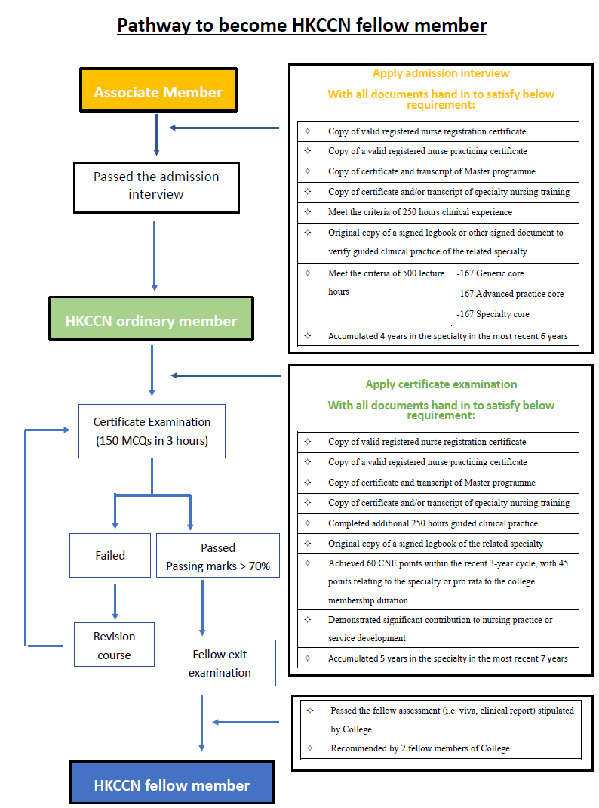
Appendix 1: Pathway to Become a Fellow Member of HKAN in Cardiac Nursing

Appendix 2: Application Information

Who can apply?
- Holder of a valid Registered Nurse (RN) registration in Hong Kong with a valid practicing certificate;
- RN who has worked in a cardiac-related specialty for an accumulated period of at least 4 years in the most recent 6 years;
- RN who has completed 500 hours of recognized theory input in the cardiac care nursing curriculum;
- RN who has completed a minimum of 250 hours of guided clinical practice in cardiac-related specialty nursing in an accredited training site(s). The guided clinical practice can be under complete supervision (100%) or with some supervision (at most 50%) in work placement situations as follows:
- 50%–100% supervised practice ^{[Note1]}
- 0%–50% work placement experience ^{[Note2]}
- Holder of a Master’s or higher Degree in Nursing or healthcare related discipline from an accredited/recognized university by HKCCN;
- No criminal conviction or professional misconduct (self-declaration).

[Note 1] Definition of supervised practice
Refers to experience with an on-site designated appointed mentor who is a fellow of HKCCN and HKAN in current practice.

[Note 2] Definition of work placement experience
- The situation in which no on-site designated appointed mentor exists. However, the experience is recognized as a learning component, with explicit learning objectives and evidence on learning assessed by a recognized supervisor/mentor.
- The evidence of learning can be, but not limited to, case studies, reflective papers, and learning contracts.

Application procedure
- The applicant should complete the application form and enclose the following documents to support the application:
- Copy of valid RN registration certification
- Copy of a valid registered nurse practicing certificate
- Copy or copies of specialty nursing related certificate(s)
- Copy of the certificates of the highest academic qualification
- Completed 250 hours of guided clinical practice in the related specialty and duly signed in logbook or other signed document to verify the hours of practice.
- HKCCN associate membership application form (for non-member only)
- No criminal conviction or professional misconduct (self-declaration)

- Those duly completed applications with all the required documents received by HKCCN will be vetted by the Examination Committee of HKCCN for the eligibility to sit for the admission interview

- The Secretariat will inform eligible applicants of the details of the interview procedure.

- ‘Admission Interview for Ordinary Membership’ and ‘Assessment for Fellow Membership’ are two separate applications. Applicant who pass the admission interview will become Ordinary Member of HKAN (Cardiac). The applicant must became Ordinary Member of HKAN before he/she will be allowed to apply for the ‘Assessment for Fellow Membership’, and must pass both parts before he/she can be eligible to apply for Fellow membership of HKAN (Cardiac – medical OR surgical OR rehabilitation).

- Please note that if the bearer’s name on the documentary proofs appears differently, the applicant may be required to approach a statutory body to make a statutory declaration verifying different names appear on the documentary proofs submitted for his/her application are all referring to the same person. The original/notarized copy of the statutory declaration should be sent to HKCCN for assessment upon request.

- Deadline of application
- 12th April 2024
- Those duly completed applications with all the required documents received by HKCCN by 12th April 2024 will be assessed and the applicants concerned will be notified whether they are eligible to sit for the admission interview.
- Please complete the application form, mail it together with the needed documents to:
Administrative Office, Hong Kong College of Cardiac Nursing,
Hong Kong Academy of Nursing
Unit 4-5, 6th Floor, Nan Fung Commercial Centre,
19 Lam Lok Street, Kowloon Bay, Kowloon.

- interview arrangement
- Tentative date of interview: In 4th May 2023, venue to be confirmed
- A candidate would sit for an hour admission interview

- Re-taking of admission interview
Candidates who are not accepted after the admission interview need re-apply the interview in subsequent calling.

